Parental Consent Form

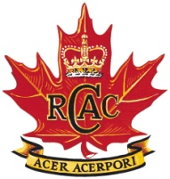
1705 RCACC 250-503-1705

PARENTAL PERMISSION FOR A PROPOSED TRAINING ACTIVITY

Exercise: Army Cadet League Shoot

Eligible Cadets – all

Date: 19 Jan – 20 Jan 2019
Cadet Drop Off: G20 – 19 Jan 19 0900 hrs
Cadet Pick Up: G20 – 20 Jan 19 1400 hrs

OIC: Capt Brunskill
OPI:

1. I, the undersigned, parent/guardian of Cadet ____________________________________________, state my cadet will/will not
Cadet Rank, Initial, Surname circle one
be attending the above exercise. Medical care card # _____________________

2. I understand if this status changes my cadet is to notify the Officer in Charge (OIC).

__________________________________________ ________________
Parent/Guardian Signature Date

Brunskill ML
Capt

